“Learning Together, Achieving for Life”
"Dysgu Gyda'n Gilydd, Cyflawni am Oes"

13th January 2017
16th Edition

KS2 DELVE & DISCOVER
KS2 had an exciting launch to their new topic, Ancient Egyptians, with a wonderful Delve & Discover Day. The school was decorated with Ancient Egyptian artefacts & posters and the staff had arranged four wonderful activities to ensure the children were immersed in all things Egyptian!
“We learnt a song and it was really good because it was about our new topic, it was rock and roll and I thought the actions were really good. We liked that the teachers were all dressed up. We’ve also learnt how to write using Egyptian letters called hieroglyphics.” Lowri, Phoebe & Evan, Year 3
“It’s been really fun. When we were learning about mummification, it took lots of practise and we had to remember the order and we all had different jobs to do. The code cracking session was quite hard because we had a wheel with different pictures and they matched letters of the alphabet. They were called hieroglyphics and we enjoyed writing with them.” Matilda & Libby, Year 4
“We went around different classes and made Egyptian collars and in Y5, we learnt an Egyptian song. I think it was good because you get to learn different things.” Myles, Year 5
“We really enjoyed our Ancient Egyptian experience and have learnt so much we didn't know before today. We've really enjoyed it. We really appreciate that the teachers have worked so hard to make this an amazing day and we can use it in our future lives.” Harry & Morgan S, Year 6
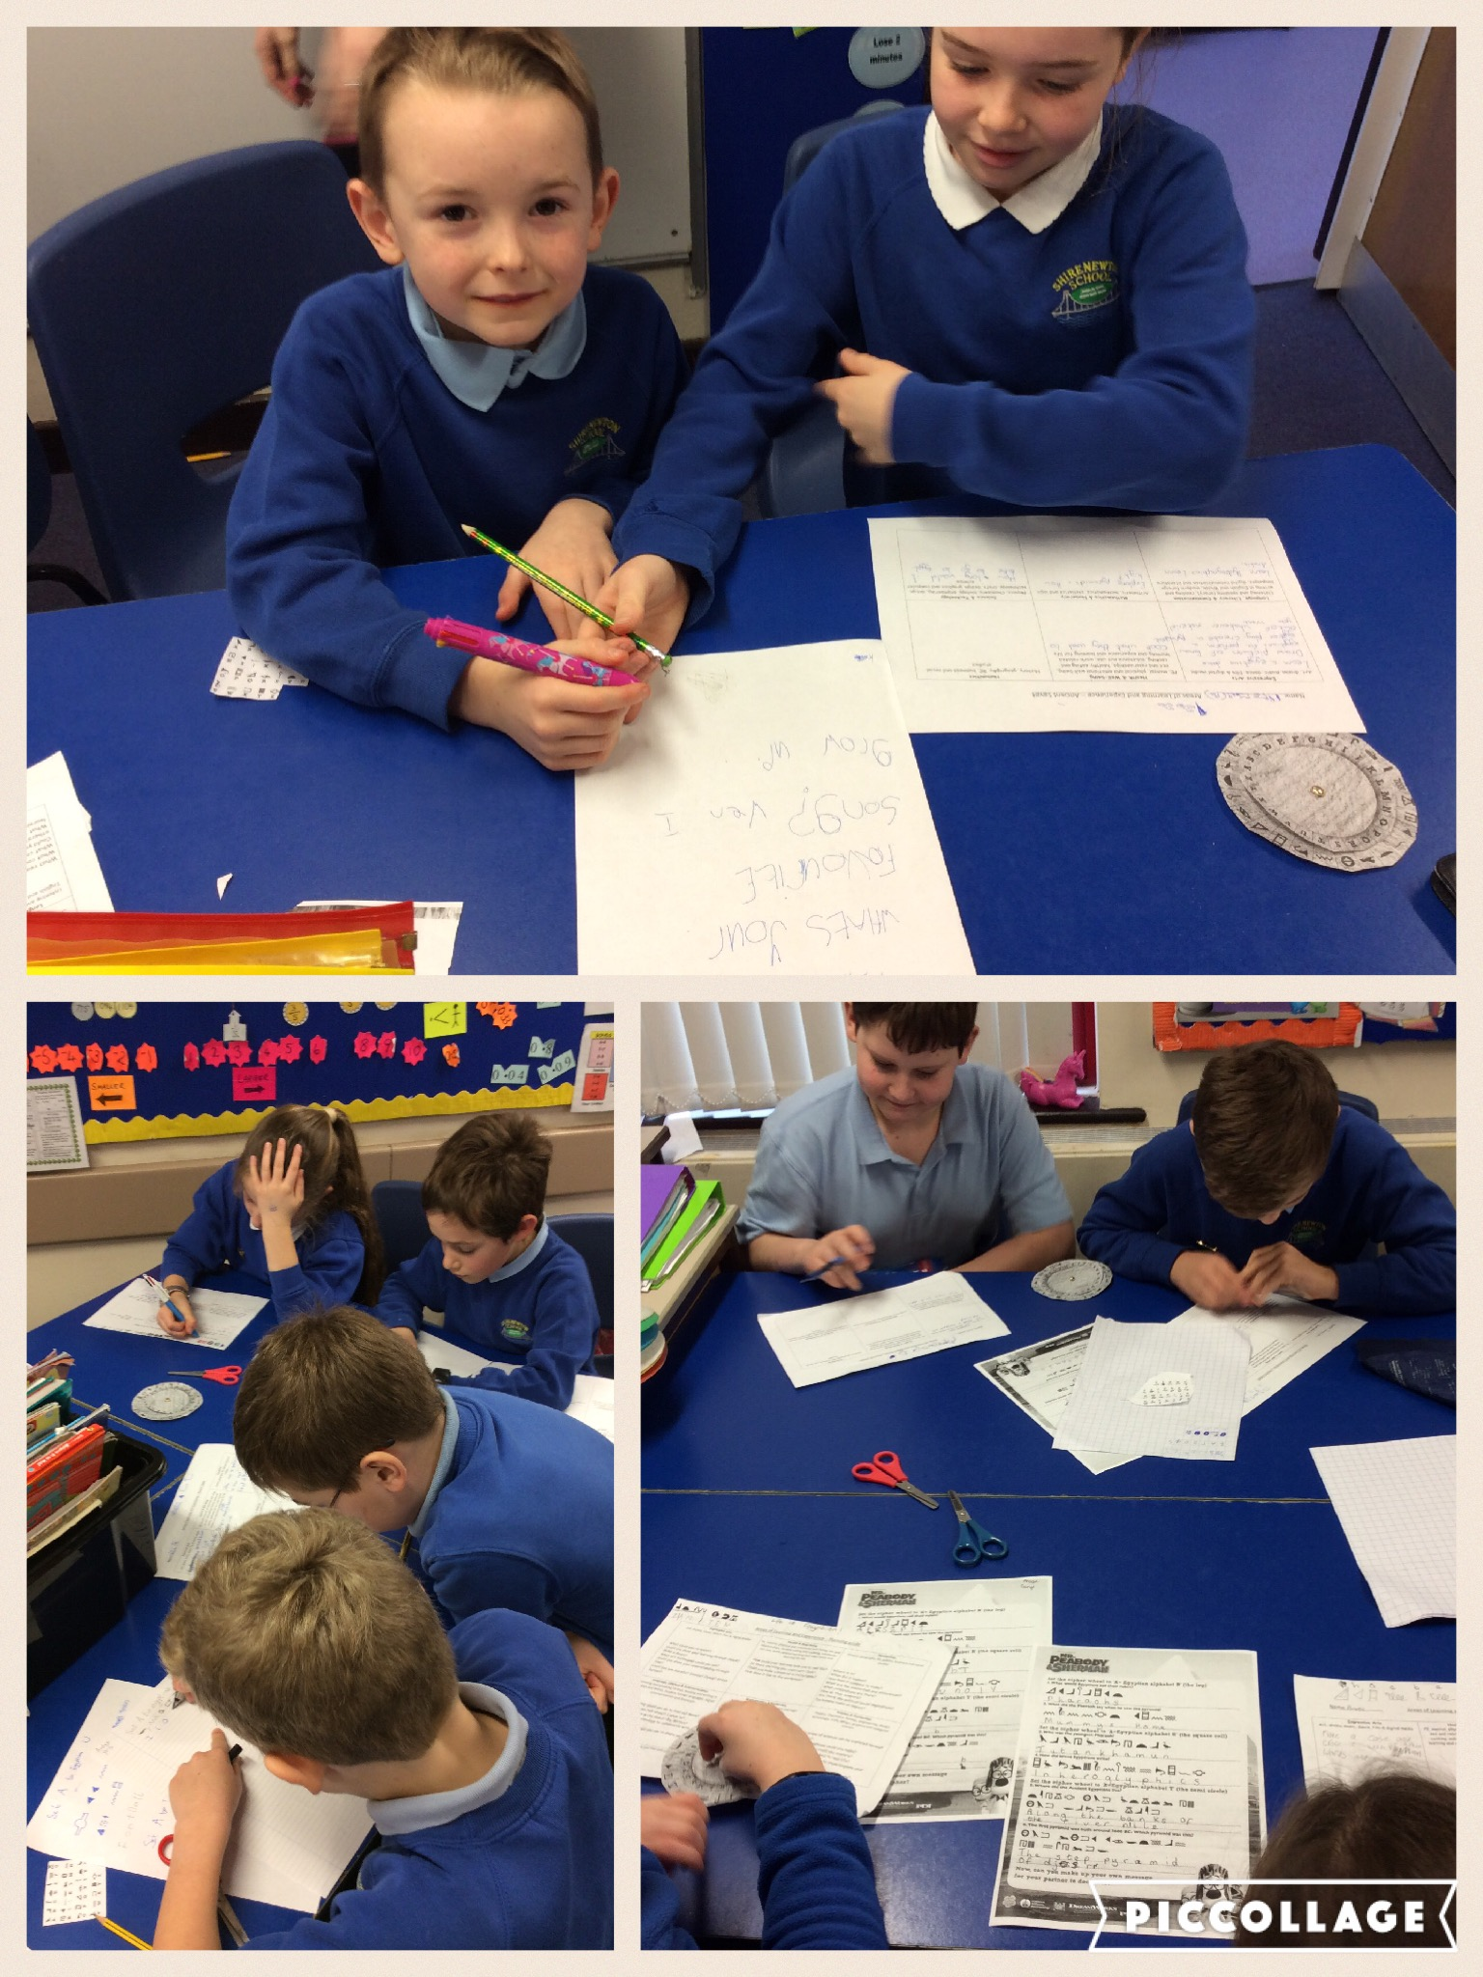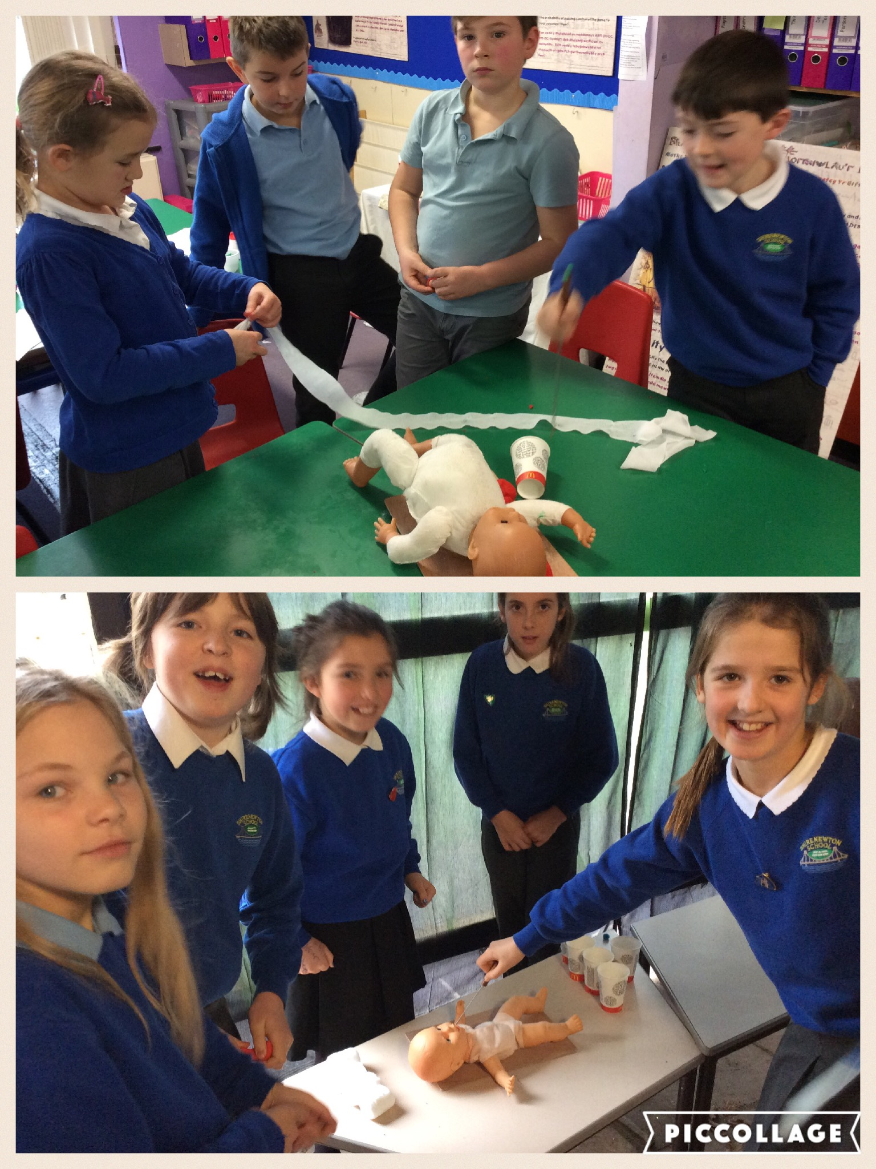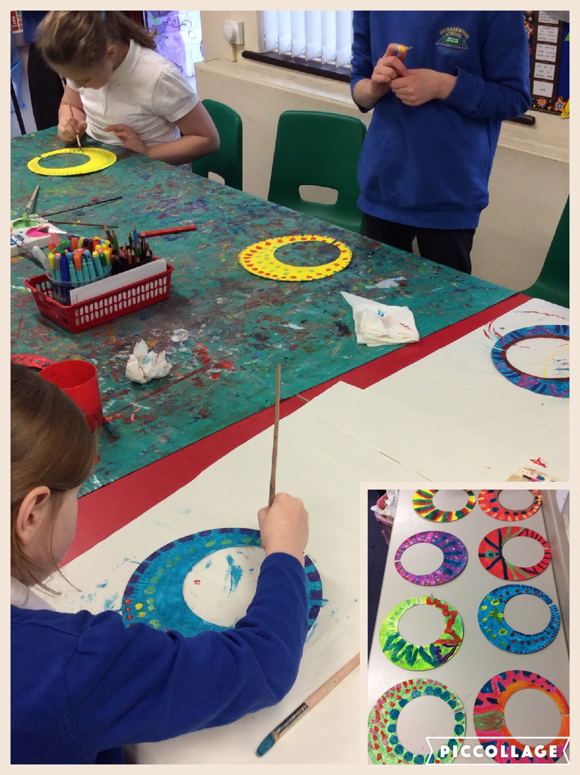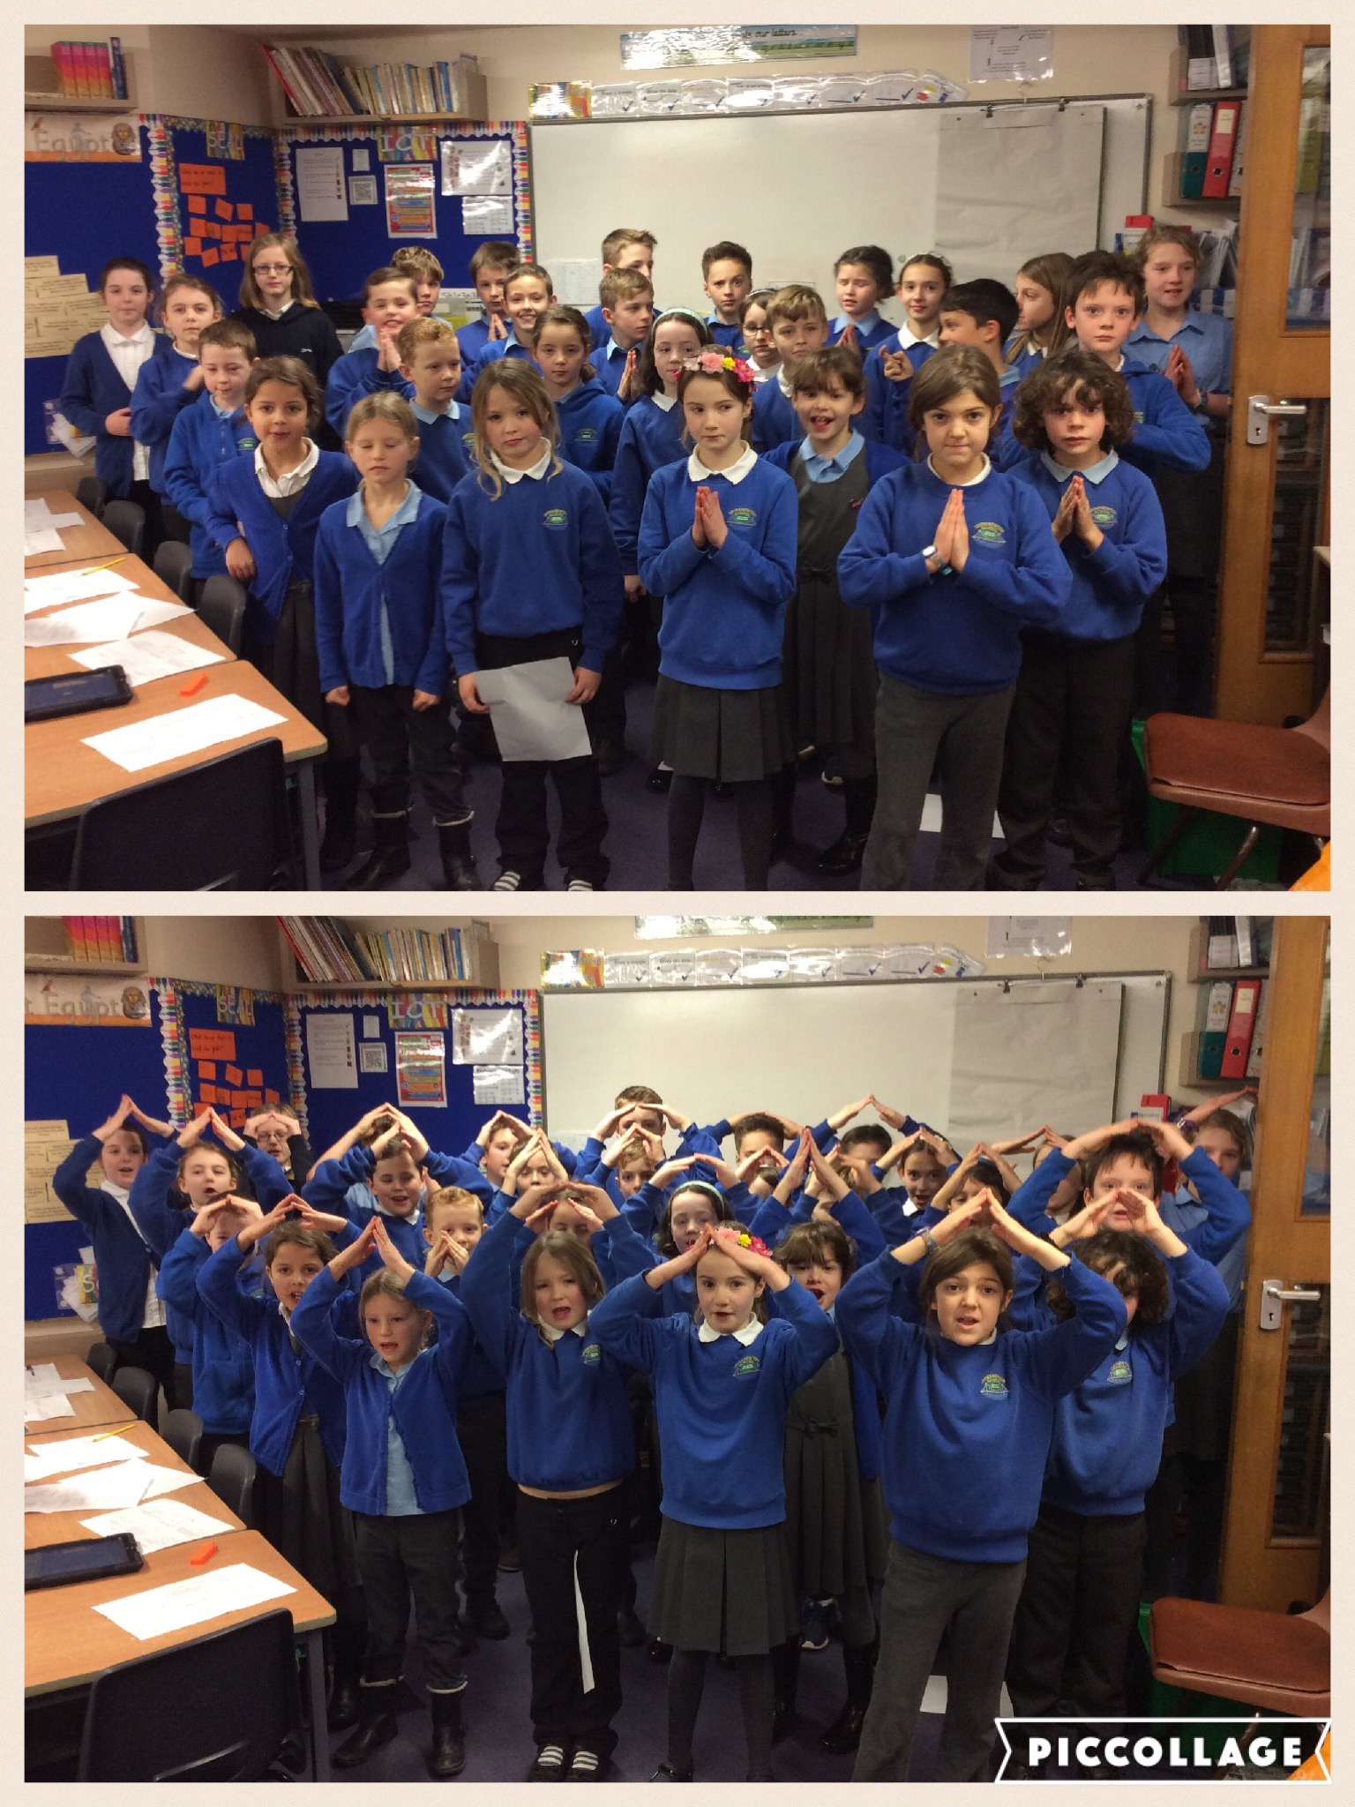

HWB
Y1-Y6 children should have all come home with usernames and passwords this week for a learning platform called Hwb. By logging into http://hwb.wales.gov.uk/, they have access to Office 365, Encyclopaedia Britannica and J2e, where they can play, create and learn using technology.
They have been introduced to it in class and will be using it in future ICT lessons as well as across the curriculum.
SCHOOP
Some people may not have been receiving alerts properly lately. The easiest thing to do, should this happen, is remove the app completely and download again; this seems to solve the problem. Otherwise, go to https://schoop.zendesk.com/hc/en-us/requests/new for further support. Diolch.

LUNCHTIME HELPERS
This week has seen the start of our new lunchtime helpers, with their lovely new outfits. They encourage the children to make healthy choices and eat sensibly.
“We are responsible for helping out Foundation Phase whilst they’re eating, by showing them correct table manners. We help by cleaning up after the others and scraping the trays. We really enjoyed helping them.” Hannah & Maddy, Year 5

CROSS COUNTRY FINAL
Despite the snow at school, it was fine down at Caldicot Castle and Cross Country went ahead. The children all ran brilliantly and some children received medals as follows: Pippa & Bethan, racing in the Y5/6 age category received 2nd & 3rd place medals respectively. A fantastic achievement in such a large field of children. Diolch yn fawr to Mrs Humphreys and our parent volunteers for taking them.
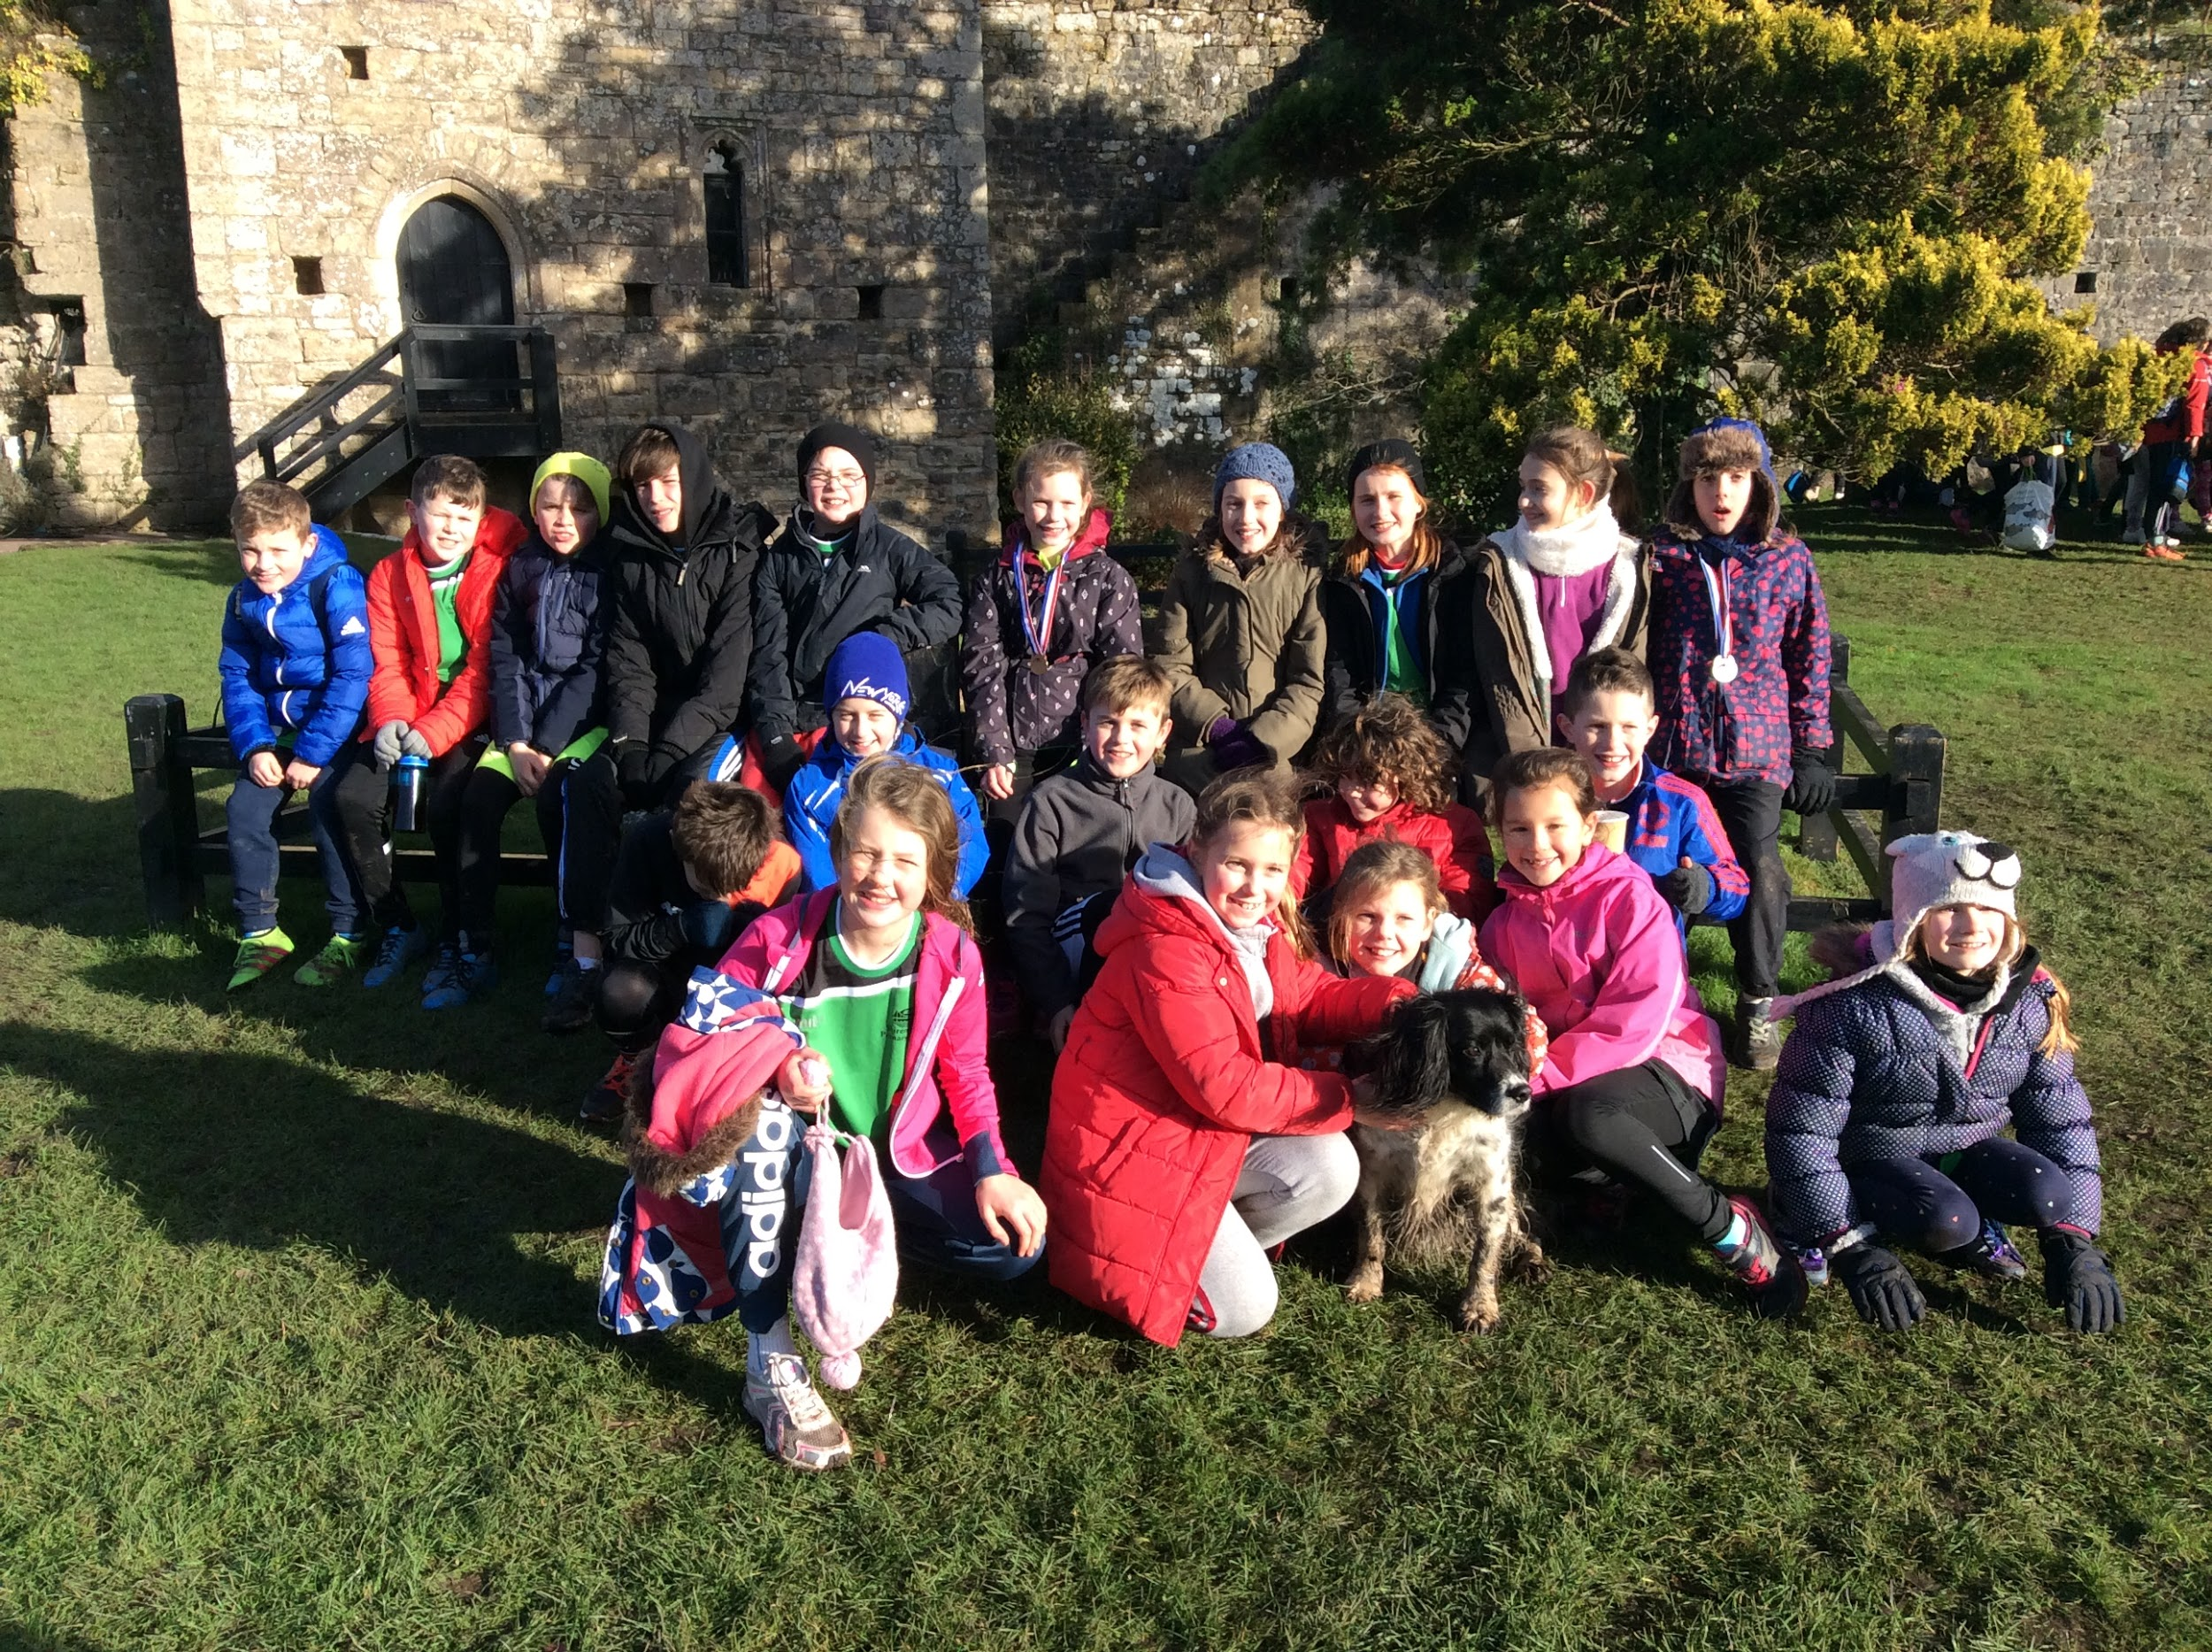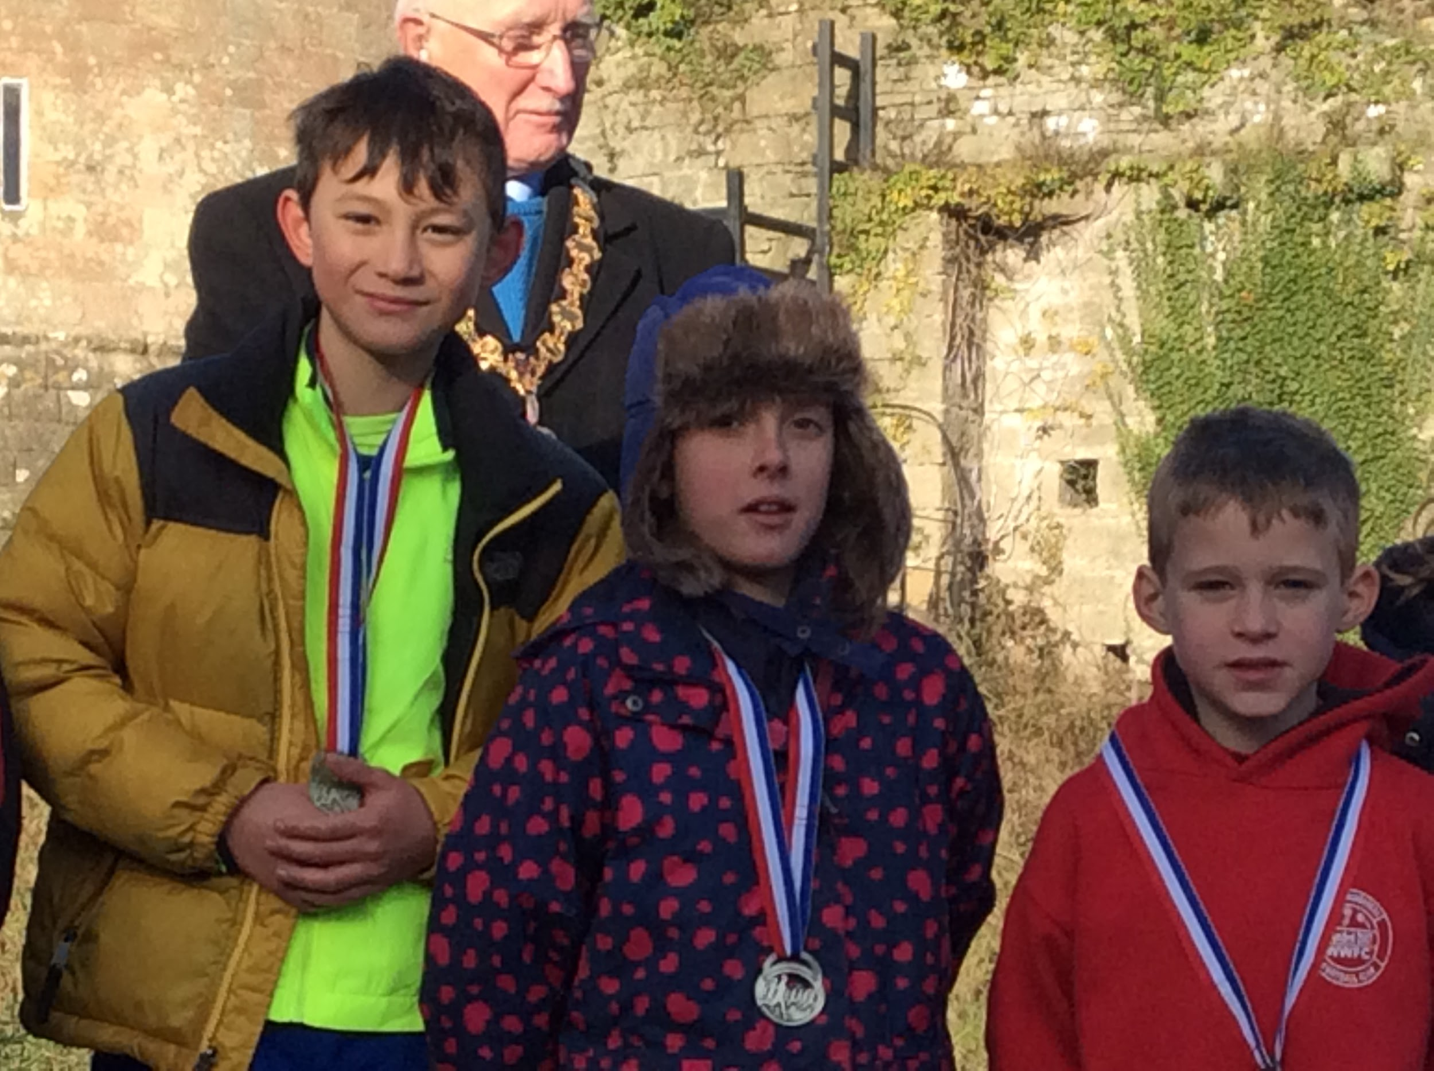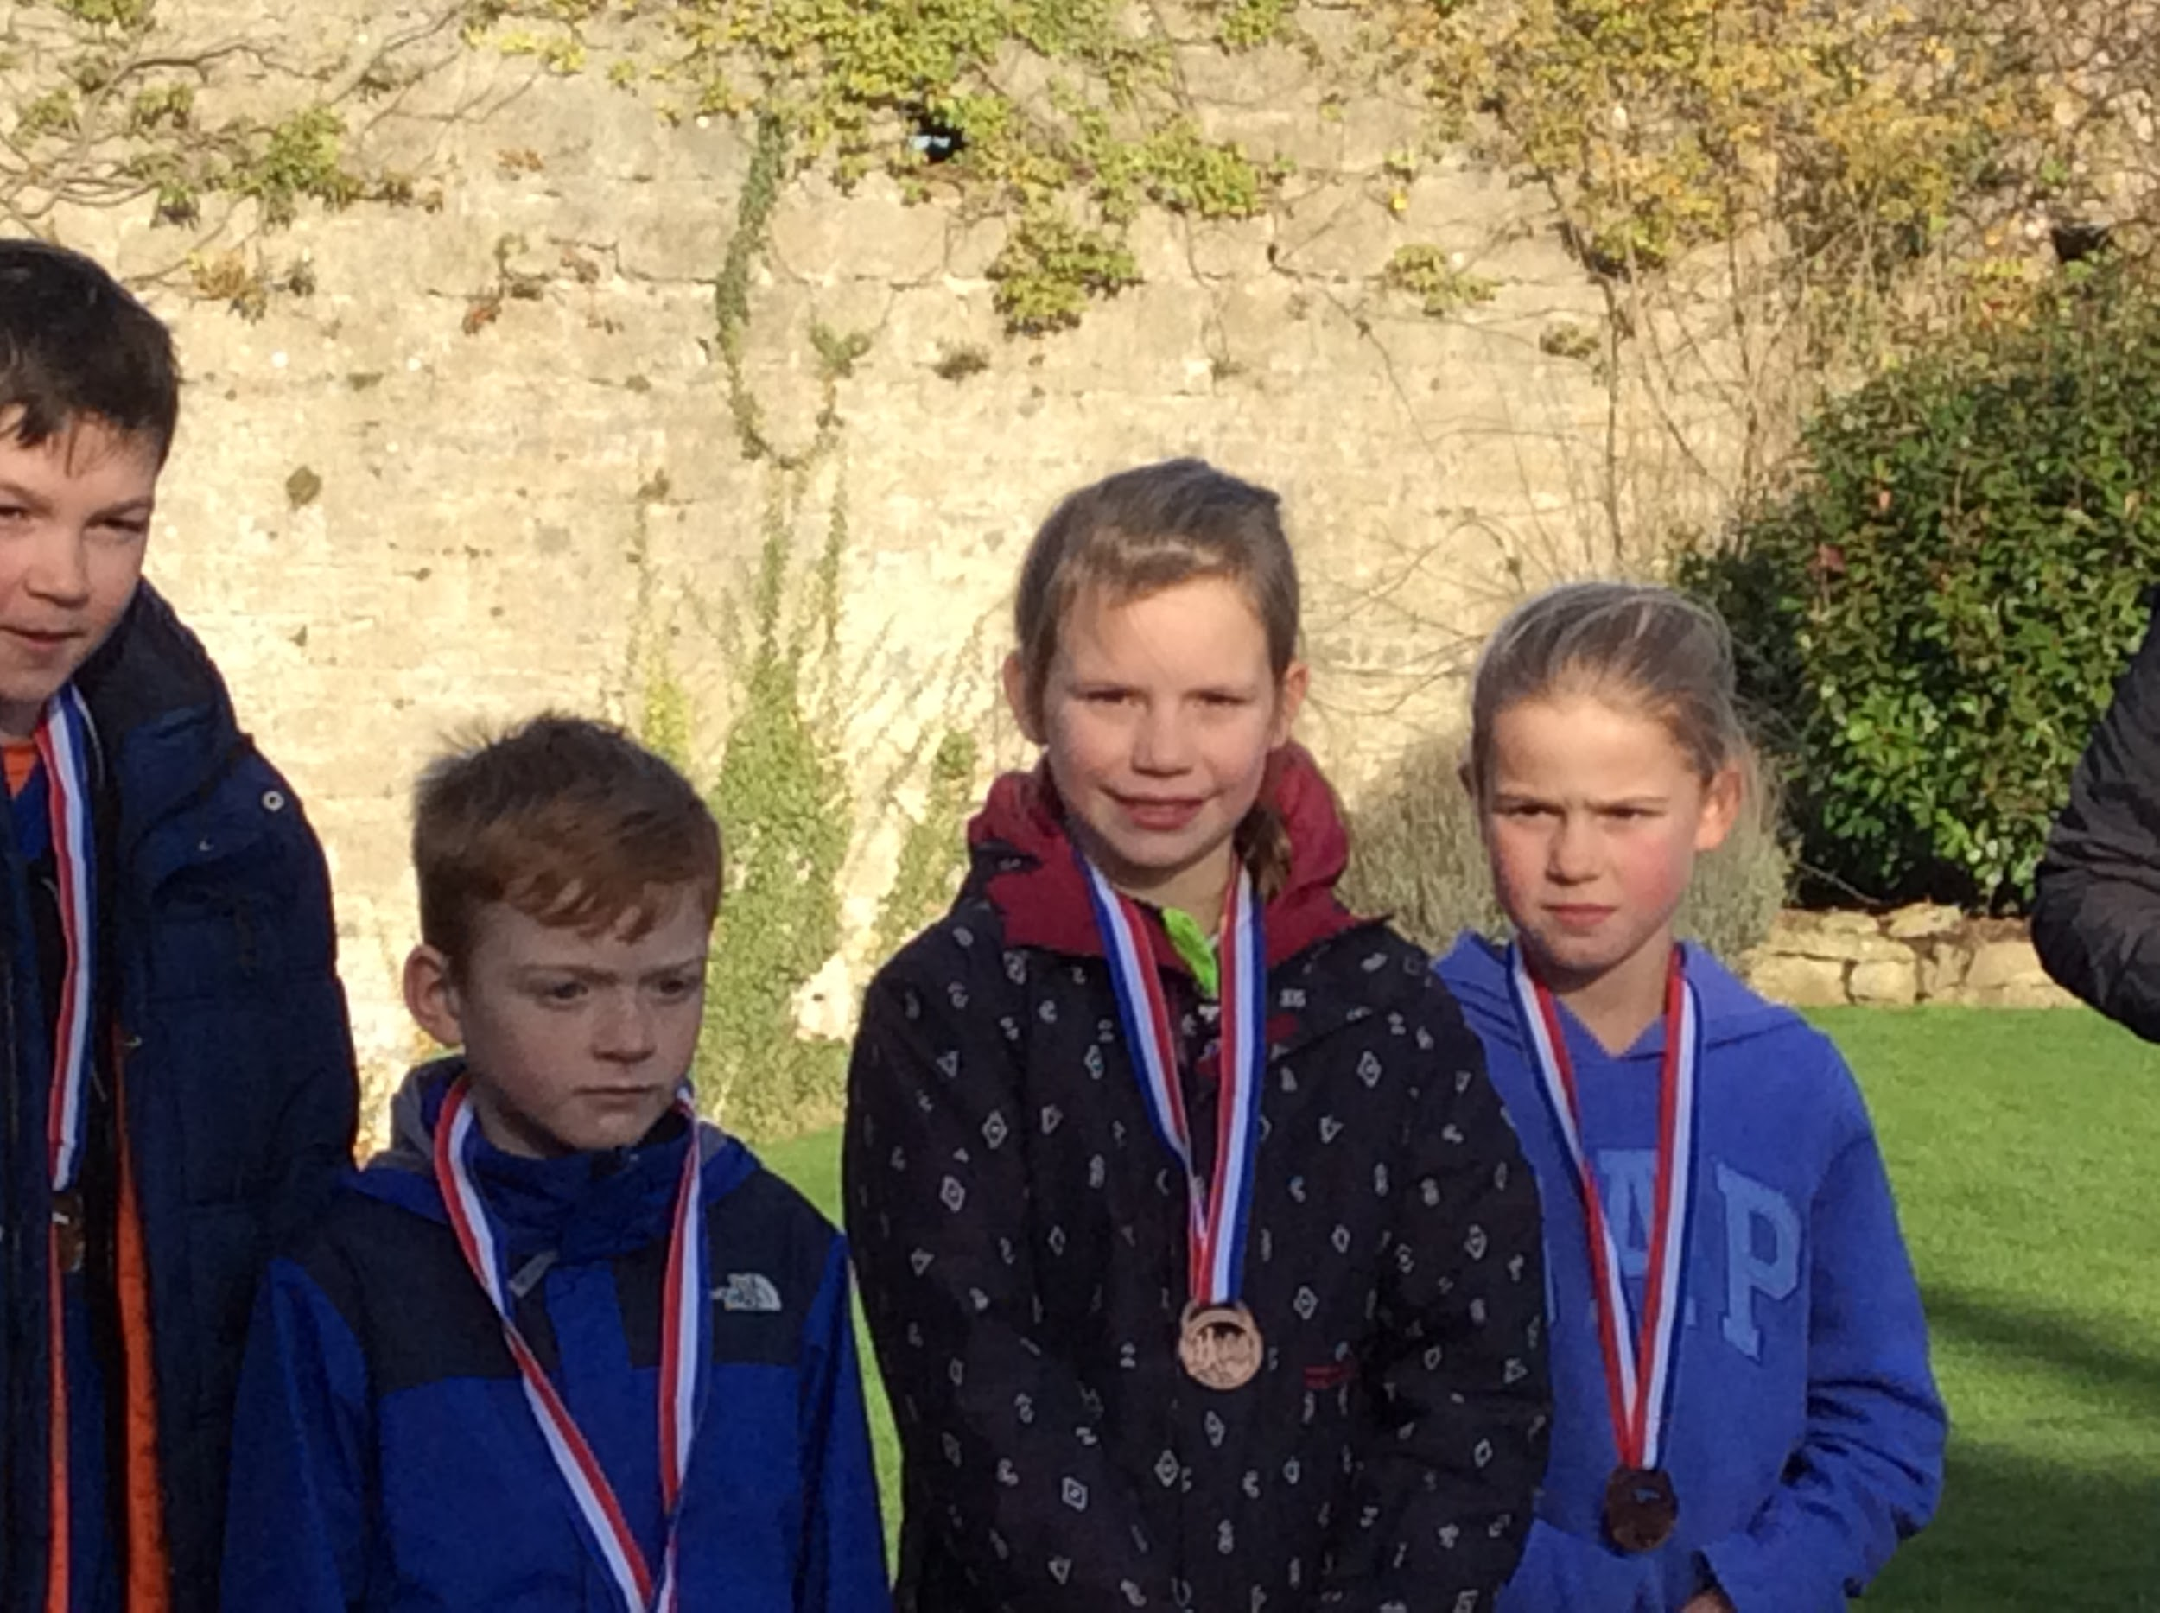

SNOW GUIDELINES
At this time of year, in the event of snow, please make sure you keep an eye on Schoop as this is the quickest, most efficient way of us communicating with you. This may be before school or during the day should conditions change/deteriorate.

REMINDERS
RECEPTION PARENTS RWINC WORKSHOP - Open to all Reception parents on Thursday 19th January at 5pm. You will learn how your child is taught phonics in school and how you can help them at home.
SWIMMING LESSONS - Year 3 are going swimming this term. The transport for the 13 weeks will cost £26 per pupil. Cheques should be made payable to Shirenewton Primary School.

HEADTEACHER AWARDS
This week’s head teacher certificates were awarded to:
Rec | Y1 | Y2 | Y3 | Y4 | Y5 | Y6
James  Sam  Jessica R |  | Lauren  Floelyn  Seren | Henry  Reuben  Ella | Emily  Morgan  Frankie | Maddy  Archie  Carys | William L  Arran  Brynn

GOLDEN TICKET WINNERS
Lucky golden tickets winners this week were:
Rec | Y1 | Y2 | Y3 | Y4 | Y5 | Y6
Llewi  Anwen  Seb | Molly  Iestyn  Milo | Zak  Barnaby  Owen | Ethan  Mia  Eloise | Libby  Jayden  Frankie | Rhianwen  Ella  Cailin | Dylan  Grace

PTA NEWS
The PTA are currently putting together a “Friends of the PTA” list. If you cant attend the monthly meetings, or don’t wish to be involved in event planning, but would be prepared to volunteer your time at the events themselves, then please contact us at r.dalton1976@outlook.com. Leave your name, the year group your child/children are currently in, and either your phone number or email address. We can then add you to our list of dependable helpers.

If you would like to participate in planning our next school events, the next PTA meeting will be held on Monday 6th February, 6.30pm, in the school, where we will be discussing upcoming discos, charity collections and fundraising events. All new faces welcome.

SPRING TERM DATES  Please note: New dates in red to help you spot them! | SUMMER TERM DATES
Mon 9th Jan - Y3 Swimming on Mondays - 13 weeks  Mon 9th Jan - PTA meeting at school 6.30pm  Tue 10th, Wed 11th, Thu 12th - Reception Parents Evenings  Tue 10th Jan - KS2 'Delve & Discover' day  Fri 13th Jan - Cross Country Final 10am  Mon 16th Jan - Y4 to Science Lesson in Comp 1.45pm  Wed 18th Jan - Y6 Parents - Gilwern Meeting  Thu 19th Jan - FP 'Delve & Discover' day  Thu 19th Jan - FP Enrichment Afternoon  Thu 19th Jan - RWI workshop for Rec parents 5pm  Mon 23rd Jan - Hearing retests for selected Rec pupils  Thu 26th Jan - FP Enrichment Afternoon  Mon 30th Jan - Governors' Meeting  Wed 1st Feb - Open Morning for parents (Maths)  Thu 2nd Feb - FP Enrichment Afternoon  Thu 9th Feb - FP Enrichment Afternoon  Fri 10th Feb - Football Final at Caldicot Leisure Centre  Mon 13th Feb - Welsh Fortnight starts  Mon 13th Feb - Curriculum Cymraeg Workshops all day  Tue 14th Feb to Fri 17th Feb - Y6 to Gilwern  * * *  Mon 20th Feb to Fri 24th Feb - Half Term  * * *  Wed 1st Mar - St David's Day Eisteddfod  Fri 3rd Mar - Welsh Fortnight ends  Mon 6th Mar - Y4 trip to Hilston Park  Tue 7th Mar - Wildlife Quiz 1st Round (4 x Y6 pupils)  Wed 8th Mar - Parents Evening 4-7pm  Thu 9th Mar - Parents Evening 4-7pm  Fri 10th Mar - Eisteddfod Coffee Morning 9.15am  Tue 21st Mar - Wildlife Quiz 2nd Round  Fri 24th Mar - Red Nose day  Mon 27th Mar - Governors' Meeting  Fri 31st Mar - KS2 Enrichment Day  Tue 4th Apr - Y3 trip to Gilwern  Wed 5th Apr - Easter Assembly 9.30am - Y1 & Y4 parents are invited  Fri 7th Apr - Last day of Spring Term  Mon 10th Apr to Fri 21st Apr - Easter Holiday | Mon 24th Apr - Back to school  Tue 25th Apr - Y1 Forest School  Mon 1st May - May Day  Tues 2nd May - Y1 Forest School  Wed 3rd May to Wed 10th May - National Tests for Y2 - Y6 (No holidays authorised during this week)  Thu 4th May - FP Enrichment Afternoon  Tue 9th May - Y1 Forest School  Thu 11th May - FP Enrichment Afternoon  Tue 16th May - Wildlife Quiz Final  Tue 16th May - Y1 Forest School  Thu 18th May - FP Enrichment Afternoon  Tue 23rd May - Y1 Camp Fire  Thu 25th May - FP Enrichment Afternoon  * * *  Mon 29th May to Fri 2nd Jun - Half Term  * * *  Fri 9th Jun - Sports Day (KS2 at 9.15am & FP at 1.45pm)  Mon 12th Jun - Growth & Vision tests for Reception  Wed 14th Jun - Reserve Sports Day  Wed 14th Jun - New Reception parents meeting 6pm  Mon 19th Jun - Governors' Meeting  Fri 23rd Jun - Reserve, Reserve Sports Day  Mon 3rd Jul - INSET (Self Evaluation with Govs)  Mon 3rd July to Friday 14th July - Transition Fortnight  Fri 7th Jul - Reports to go home  Mon 10th Jul - Pupil Committee Elections  Tue 11th Jul - New Reception visit pm & lunch  Wed 12th Jul - Open Afternoon 2pm  Wed 12th Jul - Parents Evening for those that request it 4pm - 5.30pm  Wed 12th Jul - Music Event 6pm  Thu 13th Jul - New Reception visit pm & lunch  Wed 19th Jul - Y2 Graduation 9.30am - Y2 parents are invited  Thu 20th Jul - Y6 Leavers' Assembly 9.30am - Y6 parents are invited  Fri 21st Jul - Last day of academic year

COMMUNITY CORNER
Chepstow Community Fit Club at Chepstow Rugby Club. (Western Ave, Bulwark, Chepstow NP16 5NW. Nr Homebase.)

Monday 8p.m & Wednesday 7.30p.m

A not for profit Fit Club designed to give affordable fitness twice a week to the local community.

It is run on a donations based principle, you turn up and pay however much you wish for that session. (Recommended minimum of £1)

Search for "Chepstow Community Fit Club" on Facebook.

______________________________________________________________

