“Learning Together, Achieving for Life”
"Dysgu Gyda'n Gilydd, Cyflawni am Oes"

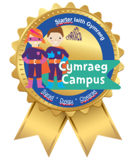
9th September 2022
Edition 2
November
End End

WELCOME BACK!
It has been wonderful to have the children back in school this week. We have seen the return of whole school assemblies which have been an absolute pleasure; their beautiful singing filling the hall has been sadly missed. We have also all returned to the hall for school dinners and we have been very impressed with their behaviour and attitude. Mrs Orford has enjoyed her first couple of days in school and has been overwhelmed by how welcoming and polite the pupils are.
Dal a ti! Keep it up!

PARENT FORUMS
As you will have seen in last week’s diary events, it is Parent Forums next week. We are holding them all at 5pm at school, in the hope that as many of you will be able to attend as possible. It is a wonderful opportunity to meet the teachers, each other, find out our approach to learning, how you can support your children at home and for you to ask any questions that you may have.

ONE WAY SYSTEM
Now that Covid restrictions have been relaxed, we will no longer have the one-way system in operation around school, however we will be keeping the path around the turning circle for now, as it allows for an easier flow around school.

BREAKFAST CLUB & ASC PARKING
Diolch yn fawr to those who drop off and collect their children at the parent car park. A reminder to others that the staff car park is only to be used by staff, diolch.

HEALTHY SNACK
A reminder that the children only need to bring one healthy snack to school for morning snack/playtime.

Please ensure you have Schoop set to the correct year groups for your children. To do this, go to My Schoop > Shirenewton School > Settings cog > Change Groups
Our Schoop ID is 10134
SWIMMING
Y5 are swimming this half term. We ask for a contribution towards the cost of transport and this will have been shared with you on ParentPay.

PUPIL COMMITTEES & HOUSE CAPTAINS
It is our pleasure to hold elections on Thursday next week for our Pupil Committees and House Captains. The children who hold these positions make incredibly important decisions for our school and we invite them to apply for up to two committees; we want them to choose something that they are passionate about and feel that they could make purposeful contributions towards. They will need to prepare a manifesto and deliver it to their classmates on Thursday. Everyone will then cast their votes in ballot boxes and the successful candidates will be announced on Friday 16th. The roles available are as follows:
Community Ambassadors - Y1-6
Criw Cymraeg - Y1-6
ECO Committee - Y1-6
Digital Leaders - Y4-6
Healthy Schools - Y1-6
School Council - Y1-6
HEDDLU BACH
Year 6 children can apply to be a member of the Heddlu Bach. If they are interested in this role, they can pick up an application form from Mrs Graham.

PUPIL LEADERSHIP TEAM
Year 6 also have the opportunity to apply to be a member of the Pupil Leadership Team. They are able to collect an application form from the Headteacher’s Office, which will need to be filled in and submitted by Friday 16th September. We will then hold interviews the following week.

TRIM TRAIL
We are incredibly grateful to Melinda in ASC and all of you for your PTA contributions over the past couple of years, as it has enabled us to purchase and install the wonderful Trim Trail over the summer holidays. The children have loved playing on it this week and it has been a great addition to our outdoor spaces.
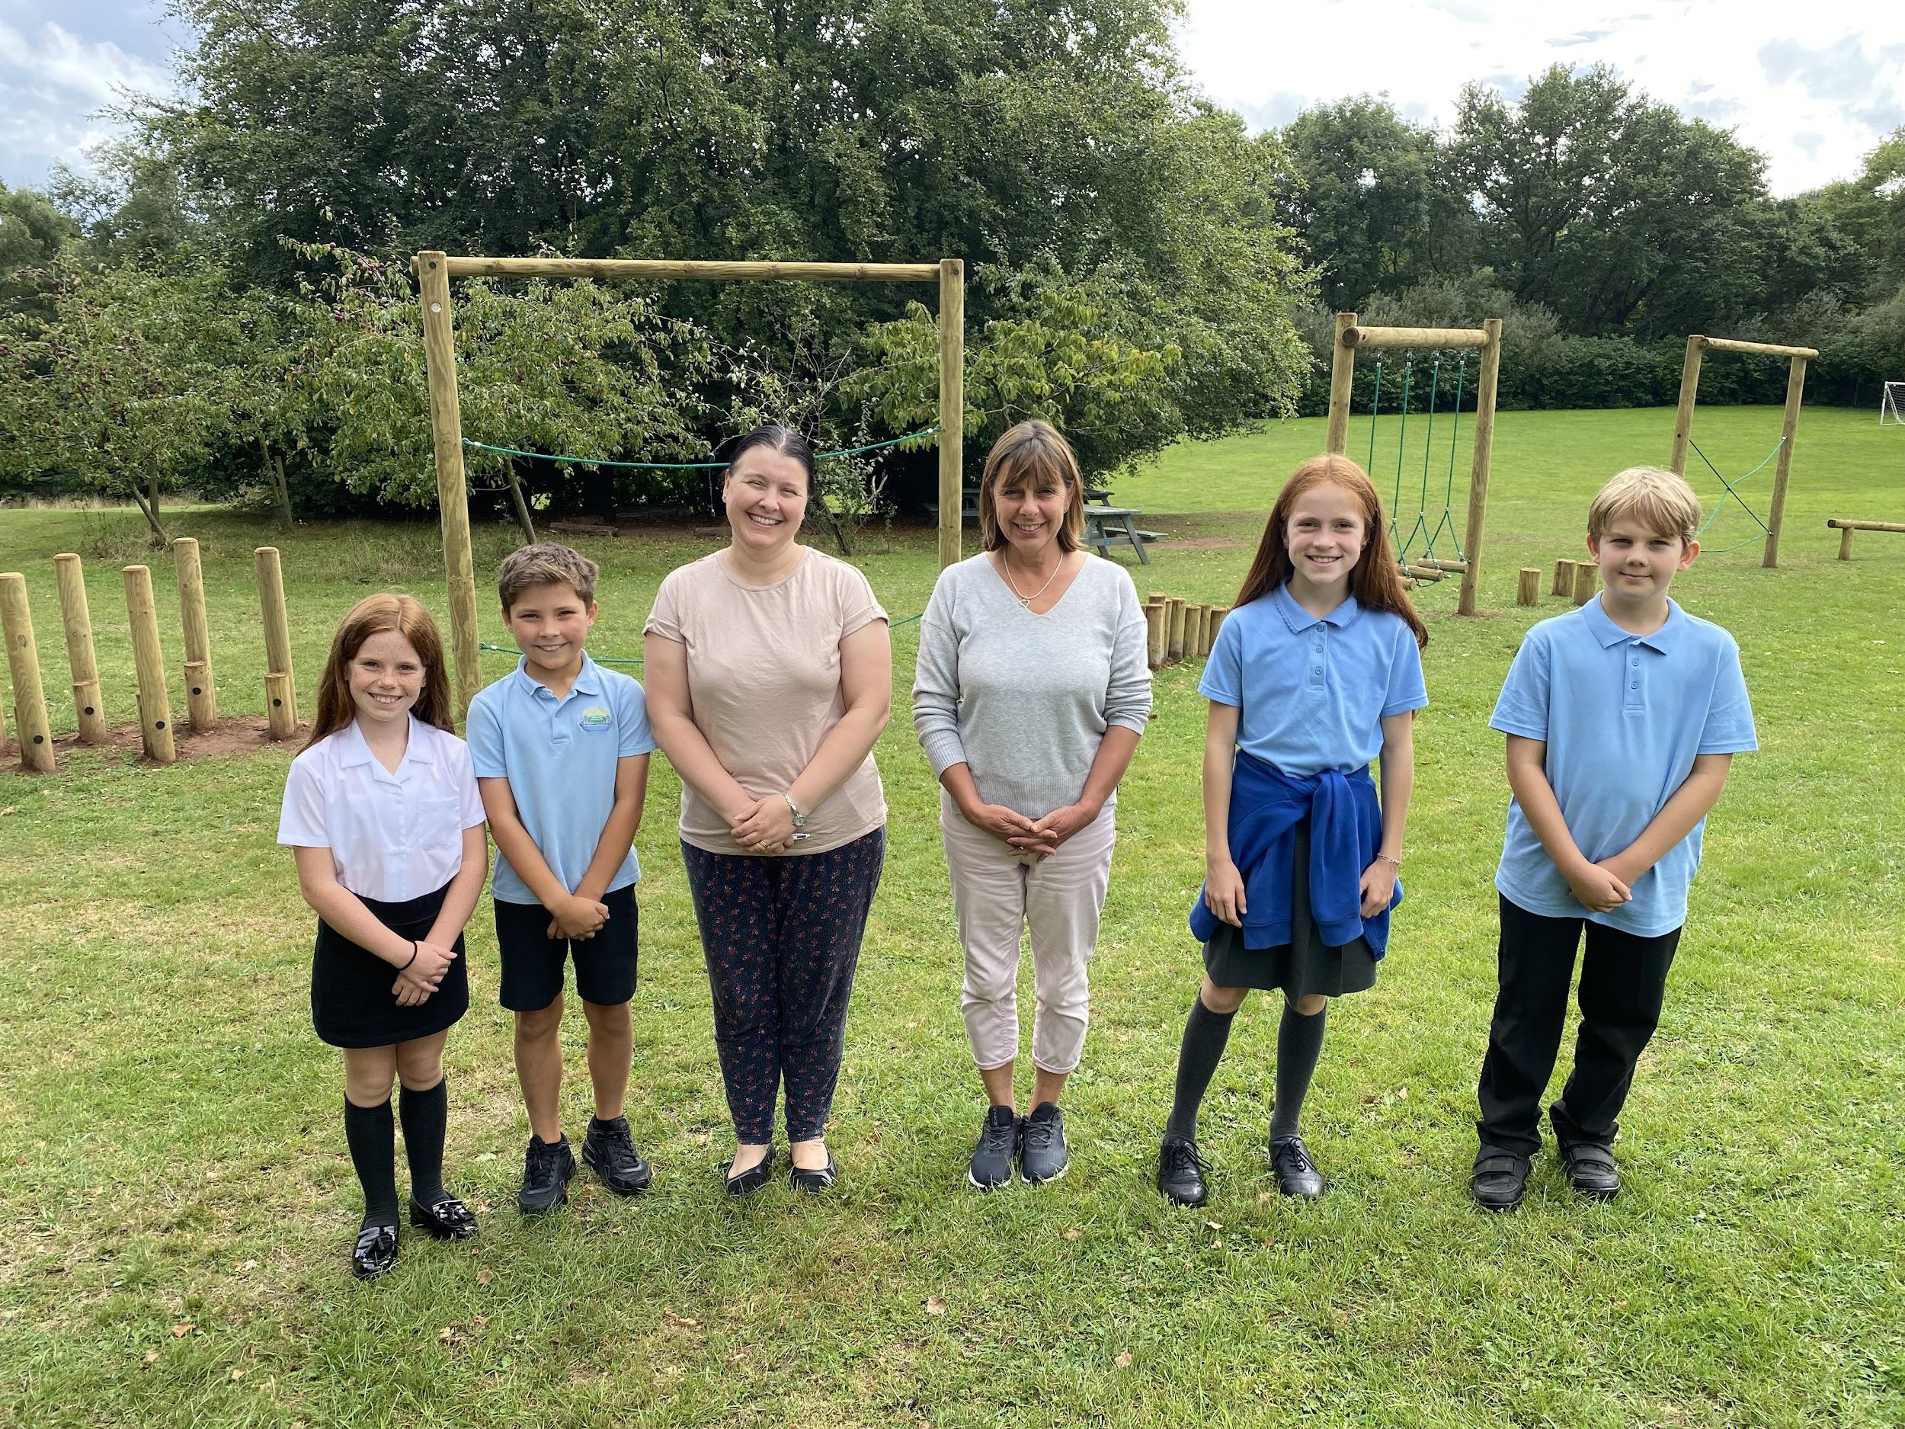

ASSEMBLIES
Monday - Talents & Achievements
During Monday assemblies, the children are given an opportunity to share their talents and achievements. They are welcome to bring in certificates, medals or cups to share with the school.
Due to the number of children in assembly, we will do Y1, Y3 & Y5 next week (12th) and then Rec, Y2, Y4 & Y6 the following week (19th) and continue to alternate.
Musicians in Assembly
We would love to hear the children perform more in school, so we are setting up a sign up sheet for each assembly. Your child is invited to bring their instrument into school to play during assembly. Please help your child sign up here.

REDUCE, REUSE, RECYCLE
Having received new tables and chairs over the summer, our old class tables are free to be reused. Perfect for greenhouses and workshops; if you’d like one/some, please let us know.
SEREN YR WYTHNOS
Congratulations to the following learners for earning themselves a headteacher certificate this week “Llongyfarchiadau” i …
Tîm Coed Coch |  | Tîm Helyg |  | Tîm Derwen |  | Tîm Collen
Dosbarth Reception | Blwyddyn Un | Blwyddyn Dau | Blwyddyn Tri | Blwyddyn Pedwar | Blwyddyn Pump | Blwyddyn Chwech
 | Charlotte  Grayson  William | Freya  Nevaeh  Oscar | Betsi  Jacob  Walter | Emily  Halli-May  Monty | Alfie  Heidi  Rocco | Annie  Evie D  Nye

TALENTS & ACHIEVEMENTS
Llongyfarchiadau i Evie who achieved 3rd place in Wales in the under 12’s Mountain Bike XC season. It’s a fantastic achievement in itself, but she races children from year 6 and 7 too! We are all very proud of you! Dal a ti! 🙌🏻🌟😊
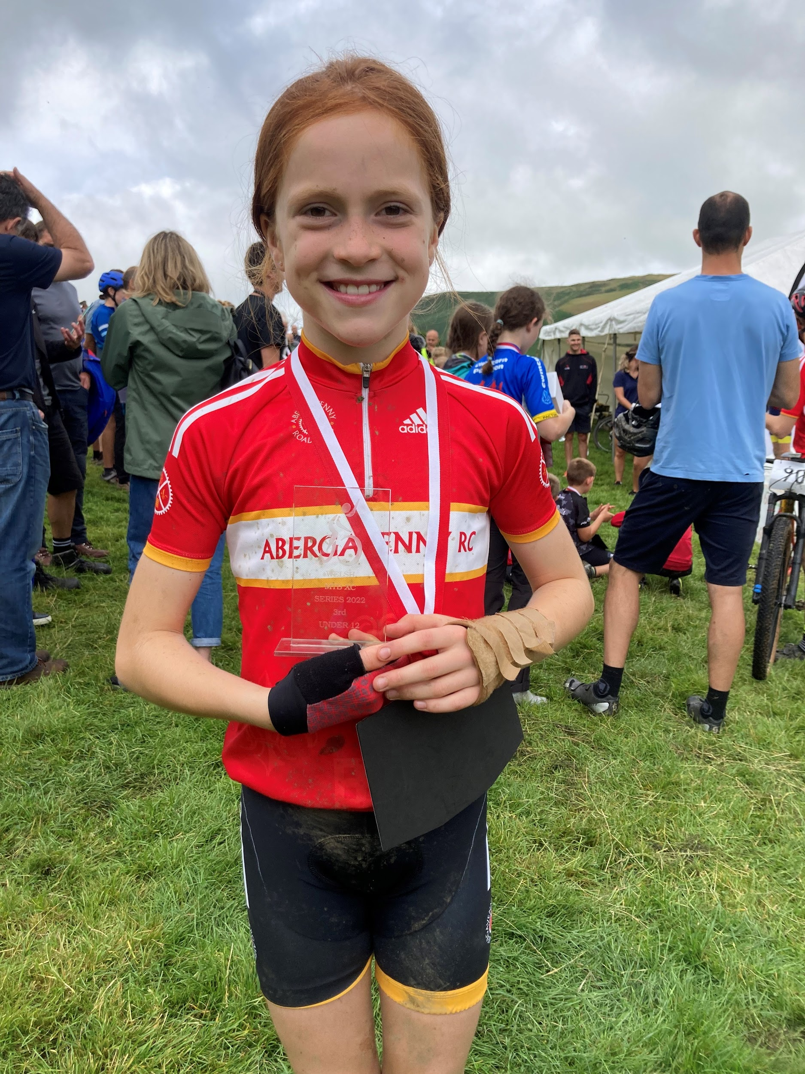
Diary Dates 2022/23
Autumn Term 2022
Any new information or changes will be highlighted
Mon 5th Sept – Back to School for Pupils  Wed 7th Sept – Y5 swimming this half term (every week until half term)  Mon 12th Sept - Y6 Parent Forum at 5pm  Tue 13th Sept – Rec & Y1 Parent Forum at 5pm  Wed 14th Sept – Y2 & Y3 Parent Forum at 5pm  Thurs 15th Sept - Y4 & Y5 Parent Forum at 5pm  Thurs 15th Sept – Pupil Committee & House Captain elections  Thurs 22nd Sept - Pupil Committee Meetings  Thurs 22nd Sept - PTA AGM 6pm, all parents/carers welcome  Fri 30th Sept - MacMillan Coffee Morning 9:15am (all parents/grandparents/carers/local community welcome)  Mon 3rd Oct - Governors' Meeting  Thurs 6th Oct - Pupil Committee Meetings  Fri 14th Oct - Diwrnod Shwmae/Shwmae Day  Sat 15th & Sun 16th Oct - SHAMBLE weekend  Thurs 20th Oct - Pupil Committee Meetings  Tue 25th Oct - Rec to Y6 Parents' Evening 4-7pm  Wed 26th Oct - Harvest Assembly - in school only for children and staff  Thu 27th Oct - Rec to Y6 Parents' Evening 4-7pm  Mon 31st Oct to Fri 4th Nov - Half term Holiday | Mon 7th Nov – Back to School  Wed 9th Nov – Y6 swimming this half term (every week until Christmas)  Thu 10th Nov - Pupil Committee Meetings  Fri 11th Nov - Flu immunisation - all classes  Wed 16th Nov - Open Morning for parents 9:15am  Fri 18th Nov - Children in Need day  Mon 21st Nov - Governors' Meeting  Thu 24th Nov - Pupil Committee Meetings  Fri 25th Nov – Rags to Riches Collection  Mon 5th Dec – Tim Helyg Dress Rehearsal  Wed 7th Dec – Tim Helyg Concert 2pm  Thu 8th Dec - Pupil Committee Meetings  Mon 12th Dec – Tim Derwen Dress Rehearsal  Wed 14th Dec - Tim Derwen Concert 1:30pm  Mon 19th Dec – Y6 Carol Concert at Shirenewton Church 6pm - tbc  Tue 20th Dec – Tim Coed Coch Christingle Service at Shirenewton Church – tbc  Friday 23rd Dec – INSET Day  Mon 26th Dec to Fri 6th Jan - Christmas Holiday

Spring Term 2023 – Key Dates
Mon 9th Jan - Back to school  Wed 11th Jan – Y3 swimming all term  Mon 23rd Jan - Governors Meeting  Fri 3rd Feb – Dydd Miwsig Cymru  Mon 20th Feb to Fri 24th Feb - Half Term Holiday | Mon 27th Feb – Back to School  Wed 1st Mar - Eisteddfod  Fri 3rd Mar - Eisteddfod Coffee Morning 9:15am  Tue 7th Mar - Rec to Y6 Parents' Evening 4-7pm  Thu 9th Mar - Rec to Y6 Parents' Evening 4-7pm  Mon 13th Mar - Governors' Meeting  Tues 28th Mar - Rags to Riches collection  Thu 30th Mar - Easter Assembly 9:30am  Fri 31st Mar - Last day for pupils  Mon 3rd Apr to Fri 14th Apr - Easter Holiday

Summer Term 2023 – Key Dates
Mon 17th Apr – Back to school  Wed 19th Apr - Year 4 swimming all term  Mon 1st May - May Day (school closed)  Mon 15th May - Governors' Meeting  Fri 19th May - Sports Day 9:15am (Y4-6) & 1:30pm (Rec-Y3)  Fri 26th May – INSET Day  Mon 29th May to Fri 2nd Jun - Half Term Holiday | Mon 5th Jun – Back to school  Fri 9th Jun - Reserve Sports Day  Fri 16th Jun – School photos  Mon 3rd Jul - Governors' AGM Meeting  Wed 5th Jul – Y5 Transition morning at Chepstow School  Tues 11th Jul – Y6 Transition Day at Chepstow School  Wed 12th Jul – Y6 Transition Day at Chepstow School  Fri 21st Jul - Y6 Leavers assembly 9:30am

Please note – 3 additional INSET Days will be added to the calendar later on in the year.

COMMUNITY CORNER

UK Covid-19 Inquiry Survey
The UK Government is asking people for their views on its response to the Covid-19 pandemic.
We’re working to have the voices of people in Wales heard:
https://HaveYourSayCHCWales.uk.engagementhq.com/uk-inquiry

