School Council Meeting Minutes
20.1.22
Meeting Place: Hall
Time: 2.45
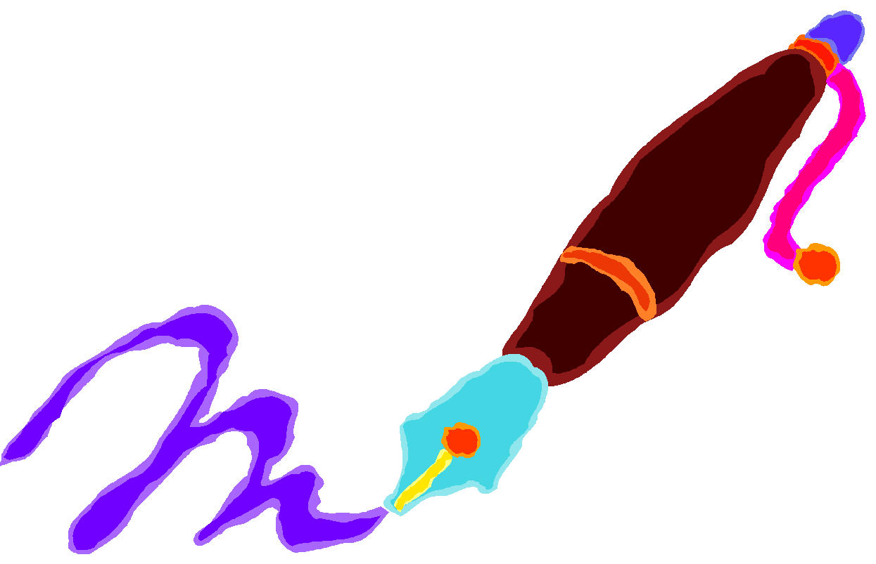
AGENDA/MINUTES/ACTIONS
Present:Millie, Tomos, Evie, James, Will, Jasmine, Henry, Ava, Amber, Jacob, Myles and Kara.
Chaired by Mrs Burgham and Evie
Apologies: None
Chair - Evie
Vice Chair - Tomos
Secretary - Millie
Vice Secretary Jasmine/James

Minutes taken today by Millie

Agenda:
- Give out badges to the children that were previously away
- Discuss Community Council Logo competition
Minutes:
Shared the conversation with Tomos about the Community Council Logo designs (visit from Keith Dunn)
Discussed and shared ideas and ways we can design the Logo. Reminded the children that Keith had mentioned that in the middle of Shirenewton is the church which could be used in logos.
Can use pens/pencils,paint or ICT
£60 prize money
Entries being collected by Keith Dunn - 14th February (entries to be completed by Friday 11th Feb ready for Monday)
Mrs Burgham to check if we can open the competition to the whole school (email Keith)
Mrs Burgham to email staff to ask for planning and design time for logos.
Next Meeting:
Logos
Discuss Ideas for Red Nose Day Friday 18th March
School Council boxes/questions/ideas
Intro/discuss Children's Rights

